# **SURFACE CRACK DETECTION ON USING IMAGE PROCESSING**

***A Paper submitted in partial fulfilment of the requirements for the award of the degree of***

BACHELOR OF ENGINEERING

IN

MECHANICAL ENGINEERING

*Under the guidance of*

ANIRBAN BOSE

*ASSISTANT PROFESSOR*



Meghnad Saha Institute Of Technology

**Submitted by**

MIRAJUL HOQUE  
*Mechanical Engineering*  
**Meghnad Saha Institute Of Technology**Kolkata, India  
**mirajul_h.me2019@msit.edu.in**

**SAYANTAN DAS**  
*Mechanical Engineering*  
**Meghnad Saha Institute Of Technology**Kolkata, India  
sayantan_d.me2019@msit.edu.in **PARTHAJIT RANA**  
*Mechanical Engineering*  
**Meghnad Saha Institute Of Technology**Kolkata, India  
parthajit_r.me2019@msit.edu.in

**SATTRAJIT SAHA**  
*Mechanical Engineering*  
**Meghnad Saha Institute Of Technology**Kolkata, India  
sattrajit_s.me2019@msit.edu.in

**SOMNATH DAS**  
*Mechanical Engineering*  
**Meghnad Saha Institute Of Technology**Kolkata, India  
somnath_d.me2019@msit.edu.in

**SHOUVIK KHAN**  
*Mechanical Engineering*  
**Meghnad Saha Institute Of Technology**Kolkata, India  
shouvik_k.me2019@msit.edu.in

**PANKAJ KUMAR**  
*Mechanical Engineering*  
**Meghnad Saha Institute Of Technology**Kolkata, India  
pankaj_k.me2019@msit.edu.in

***Abstract*—This work aims at developing a machine learning‐based model to detect cracks on concrete surfaces. Such a model is intended to increase the level of automation on concrete infrastructure inspection when combined with unmanned aerial vehicles (UAV). The developed crack detection model relies on a deep learning convolutional neural network (CNN) image classification algorithm. Provided a relatively heterogeneous dataset, the use of deep learning enables the development of a concrete cracks detection system that can account for several conditions, e.g., different light, surface finish and humidity that a concrete surface might exhibit. These conditions are a limiting factor when working with computer vision systems based on conventional digital image processing methods. For this work, a dataset with 40000 images of concrete surfaces balanced between images with and without cracks was used.Crack detection has vital importance for structural health monitoring and inspection of buildings. The task is challenging for computer vision methods as cracks have only low-level features for detection which are easily confused with background texture, foreign objects and/or irregularities in construction. In addition, difficulties such as inhomogeneous illumination and irregularities in construction present an obstacle for fully autonomous crack detection in the course of building inspection and monitoring. Convolutional neural networks (CNN’s) are promising frameworks for crack detection with high accuracy and precision. Furthermore, being able to adapt pretrained networks to custom tasks by means of transfer learning enables users to utilize CNN’s without the requirement of deep understanding and knowledge of algorithms. Yet, acknowledging the limitations and points to consider in the course of employing CNN’s have great importance especially in fields which the results have vital importance such as crack detection in buildings. Within the scope of this study, a multidimensional performance analysis of highly acknowledged pretrained networks with respect to the size of training dataset, depth of networks, number of epochs for training and expandability to other material types utilized in buildings is conducted. By this means, it is aimed to develop an insight for new researchers and highlight the points to consider while applying CNN’s for crack detection tasks. This paper is devoted to the development of a deep learning- (DL-) based model to detect crack fractures on concrete surfaces. The developed model for the classification of images was based on a DL Convolutional Neural Network (CNN). To train and validate the CNN model, a database containing 40,000 images of concrete surfaces (with and without cracks) was collected from the available literature. Several conditions on the concrete surfaces were taken into account such as illumination and surface finish (i.e., exposed, plastering, and paint). Various error measurement criteria such as accuracy, precision, recall, specificity, and F1-score were employed for assessing the quality of the developed model. Results showed that for the training dataset (50% of the database), the precision, recall, specificity, F1-score, and accuracy were 99.5%, 99.8%, 99.5%, 99.7%, and 99.7%, respectively. On the other hand, for the validation dataset, the precision, recall, specificity, F1-score, and accuracy are 96.5%, 98.8%, 96.6%, 97.7%, and 97.7%, respectively. Thus, the developed CNN model may be considered valid because it performs the classification of cracks well using the testing data. It is also confirmed that the developed DL-based model was robust and efficient, as it can take into account different conditions on the concrete surfaces. The CNN model developed in this study was compared with other works in the literature, showing that the CNN model could improve the accuracy of image classification, in comparison with previously published results. Finally, in further work, such a model could be combined with Unmanned Aerial Vehicles (UAVs) to increase the productivity of concrete infrastructure inspection.**

# ***Introduction***

Image processing is any form of processing for which the input is an image, such as a photograph or video frame. The output of Image Processing can be either an image or a set of characteristics or parameters related to an image. The fundamental principle of Image processing operations carried out will assist us in its greater perception and vision but doesn’t add any information content the recent availability of sophisticated semiconductor digital devices and compact powerful computers coupled with advances in Image processing algorithms has brought Digital Image processing to the forefront. Digital Image processing has a broad spectrum. It has varied applications such as remote sensing via satellites and other spacecraft image transmission and automates inspection of industrial paths storage for business applications, medical processing, radars and acoustic image processing robotics. Image processing is necessary because human beings are adept at interpreting images of a certain threshold beyond which we cannot detect just noticeable differences in the imagery. Human beings can detect only 8 to 16 shades of grey, even when data is recorded with 256 shades of grey. Therefore, one may not be able to interpret data in the remaining shades of grey. Also, it is necessary to continuously track large amounts of data and its storage is a problem. To avoid all these difficulties, one shall prefer processing of images by digital computers which processes at a much faster rate than human beings do.

Fig1: Positive Crack Image.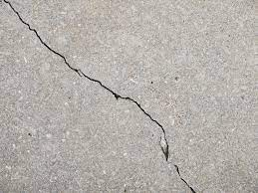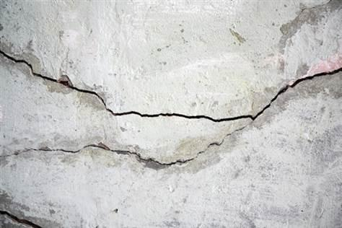

Fig2: Negative No Crack Image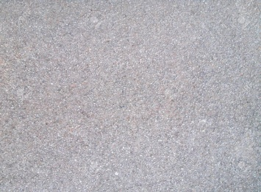

1.1 Image Processing steps 1. Importing the image via image acquisition tools. 2. Analysing and manipulating the image. 3. Output in which the result can be altered or a report which is based on analysing that image.

1.2 What is an Image? An image is defined as a two-dimensional function, F (x, y), where x and y are spatial coordinates, and the amplitude of ‘F’ at any pair of coordinates (x, y) is called the intensity of that image at that point. When x, y, and amplitude values of ‘F’ are finite, we call it a digital image. In other words, an image can be defined by a two-dimensional array specifically arranged in rows and columns. Digital Image is composed of a finite number of elements, each of which elements have a particular value at a particular location. These elements are referred to as picture elements, image elements, and pixels. A Pixel is most widely used to denote the elements of a Digital Image

1.3 WHY CONCRETE CRACKS? Cracks are of major concern for ensuring the safety, durability, and serviceability of structures. The reason is that when cracks are developed and propagate, they tend to cause the reduction in the effective loading area which brings about the increase of stress and subsequently failure of the concrete or other structures. Since there always exist constraints in ferro concrete structures and buildings deteriorate overtime, cracking seems unavoidable and altogether sorts of structures, for instance, concrete wall, beam, slab, and brick walls. Particularly for concrete elements, cracks create access to harmful and corrosive chemicals to penetrate the structure, which consequently damage their integrity as well as aesthetics. Primarily the basic question is

PROBLEM STATEMENT The objective of the project is to identify the cracks on the concrete surfaces and to estimate the parameters of the crack. Using this calculated information builders can easily estimate the strength of any concrete structure and take immediate necessary action. Concrete is a quasi-brittle material with a low tensile strength. Applied loadings, deleterious chemical reactions and environmental effects can result in the development of tensile stress in concrete. When these tensile stresses exceed the concrete tensile strength, the concrete will crack. The extent and size of cracks influence the performance of the bridges and buildings. Although this cracking can be reduced by proper selection of concrete constituent materials, some cracking is inevitable.

MOTIVATION FOR THE WORK

Image Processing at present is used in various applications. It is a fascinating and exciting area to be involved in today. Visual Information, transmitted in the form of digital images, is becoming a major method of communication in the modern age. Image Processing in future can be widely recognized and aware of cancer tumors and helps in prevention of diseases by making the person aware. Digital Image Processing deals with manipulation of digital images through a digital computer. It is a subfield of signals and systems but focuses particularly on images. Digital Image Processing focuses on developing a computer system that is able to perform processing on an image. The input of the system is a digital image and the system processes that image using efficient algorithms, and gives us an output. There are various types of tasks in Image Processing which includes Image Acquisition, Storage, Transmission; Image enhancement and Restoration; Image understanding and Recognition. All of these play an important role in the real world. Out of them, Image enhancement plays a vital role in various fields. Enhancements are used to make it easier for visual interpretation and understanding of imagery. The advantage of digital imagery is that it allows us to manipulate the digital pixel values in an image. An image ‘enhancement’ is basically anything that makes it easier or better to visually interpret an image. Also, an enhancement is performed for a specific application. This enhancement may be inappropriate for another purpose which would demand a different type of enhancement.

# ***Ease of Use***

## Image Acquisition

Although there is much research on crack detection in academia, there is no unified crack image dataset. Therefore, to train the crack detection and recognition model, it is necessary to manually collect crack pictures. The data in this experiment are based on camera collection, and the type of cracks targeted is concrete cracks. The camera is used to manually take pictures on roads and bridges to collect crack pictures. A total of 2000 crack pictures were collected, including four types of strong light, moisture, distortion, and darkness. The picture resolution is 128×128 pixels in the format of JPG.

The early methods usually assumed that the crack pixel is generally darker than the surrounding and then used various threshold processing algorithms to extract the gray of the crack area. Because the threshold segmentation method is simple and fast, it has been widely used in early image segmentation. Early researchers proposed a variety of automatic detection algorithms based on threshold segmentation from different views. Li and Liu proposed the threshold technique of adjacent difference histogram for automatic recognition of cracks in images. This method maximizes the difference between the two types of pixels (crack and non crack) and achieves better experimental results than the traditional threshold method. Paper detected crack pavement by processing the binary image obtained by the connected domain algorithm (directional segmentation expansion algorithm) and got good results.

Because the threshold segmentation method only considers the gray information of the image and ignores the spatial information of the image and is sensitive to noise, this algorithm is often combined with other methods to improve the segmentation accuracy. Gavilán et al. found that the noncrack features in the image will present false positives. Therefore, in order to obtain the crack area, it is proposed to eliminate the false positive cracks in the non crack image by calculating the average gray value of the pixels corresponding to the inner and outer contours of the linear object in the image. Li and Mao first segmented the image into several complementary overlapping subimage regions. Then, the neighborhood difference histogram was used to segment and fuse the cracks in each sub image region. Lastly, the crack region is obtained in the images. This method is effective in a small range of complex fractures, but not in a large area of complex background.

The traditional threshold extraction method lacks the description of global information and is sensitive to noise. The detection effect depends on the selection of the threshold. However, in practical application, the road background is complex and there are many noises, so there are few algorithm models applied in practice.

## Crack Recognition Dataset Build

The original collected crack pictures are only 2000. For deep-learning tasks, to obtain a model with good generalization performance and high accuracy, the quantity of data is not enough. The resolution of the original pictures is 1024×1024 pixels, and the pixels are large and not suitable for direct input to the neural network. The input image size of the neural network is too large, which will cause too much memory overhead. The number of layers of the neural network is bound to increase. The parameters of the neural network also increase exponentially, which leads to an increase in video memory and training time and a decrease in training batches, making the model show poor performance. To solve the above problems, the experiments were performed with the sliding window cropping technique, which uses 128×128 pixel window sliding on the original picture and cropping line by line without overlapping. The resolution of the cropped picture is 128×128 pixels. Then, manual classification was performed to obtain a dataset of 20,000 crack pictures and 20,000 background pictures without cracks. To improve the generalization ability of the model, it is necessary to perform data augmentation of the crack pictures, including horizontal flip, vertical flip, rotation 180, random zoom aspect ratio, random cut, brightness, and saturation change.

## Crack Detection Dataset Build

In this work, a database of images with cracks was collected from the available literature. Derived from the walls and floors of several concrete buildings at the Middle East Technical University, the database contains two categories of the concrete surface, no cracks and with cracks. The distance between the concrete surface and the camera was approximately 1 m. Both the no crack and crack categories contain 20,000 images, and each image exhibits 128×128 RGB pixels. Several samples of the database are shown in Figure [1](https://www.hindawi.com/journals/acisc/2021/8858545/fig1/). The images were captured on the same day with similar illumination. However, as various concrete surfaces were investigated (i.e., exposed, plastering, and paint) at different buildings, the variation in terms of surface finish and lighting conditions exists in these images. It should be noticed that this final database was generated from 458 high-resolution images (i.e., 4032×3024 pixels) as a data augmentation technique. The dataset was randomly split into a training and validation dataset at a 50/50 ratio.

This section provides the basic architecture for the crack detection using the image processing technique. The major advantage of the image based analysis of the crack detection is that by using the image processing technique it provides accurate results compared to the conventional manual methods. The processing difficulty of the crack detection completely depends on the size of the image. Recent digital cameras have the image resolution beyond 10 megapixels. This increase in resolution enables the acquisition of detailed images of concrete surfaces. By using the trendy cameras of commercial purpose, a wide range of a concrete surface can be acquired in a single shot. For inexpensive applications, a wide range image can be used for the practical crack detection. Architecture for crack detection based on image processing. The steps in the image processing technique are as follows:

(1) initially collect the image of the structure which will be subjected to the crack detection process using the camera or any sources.

(2) After the image acquisition, the collected images are pre-processed within which the methodologies like segmentation are done thereby making it an efficient one for the image processing procedure.

(3) In image processing, some of the techniques are employed to process the deducted image sample.

(4) The crack detection will be noticed here on the structure using the result of the processed image.

(5) Crack feature extraction is the step in which the detected cracks are separated based on the width, depth and the direction of propagation of the crack.

In the course of the experiment, the dataset played an important role; 1600 of the original pictures were used as the training set, and 200 original pictures were used as the test set. The LabelIng tool was used to mark the crack location and category of the image, generate an XML file, and then, convert it to a TXT file, which contains the category of the crack, the centre coordinates, and the length and width of the smallest bounding rectangle.Considering the speed of model training and the use of computer memory and video memory, all images are compressed to 416×416 pixels under the premise of ensuring the original image ratio, and the blank parts are filled with grey (128, 128, 128). To improve the generalization ability of the model, it is also necessary to perform data augmentation of the crack pictures, and the augmentation measures are the same as those of the crack recognition dataset

# ***Survey***

2. **LITERATURE SURVEY**

2.1 CRACK CLASSIFICATION

Cracks can be broadly classified into two categories namely active and dormant. In active cracks, the change in direction, width or depth occurs over a measured period whereas in dormant cracks it remains unchanged. If left unrectified, both active and dormant cracks provide passage for moisture penetration, which can lead to future damage. Some of the active cracks are longitudinal crack, transverse crack, miscellaneous crack, crocodile crack and reflection crack. Dormant cracks are very fine in nature and auto healing occurs over a time period. The various types of crack based on their structure are micro crack, thin crack, sealed crack, mixed crack, line-like crack, minor crack, tiny crack, medium crack, large crack and complex crack. Crack classification is an approach to find the specific crack type using machine learning algorithms. Crack detection identifies or recognizes the presence of crack whereas crack classification classifies the crack based on the feature extracted from the crack region. Machine learning is a subfield of Artificial Intelligence (AI), useful to perform classification, prediction and clustering of the dataset depends on the application. Classification/Prediction is carried out using supervised learning algorithms whereas clustering is carried out using unsupervised algorithms. The different types of supervised learning algorithms applied for crack classification are Support Vector Machine (SVM), K Nearest Neighbours algorithm (KNN). In underwater dam, it is difficult to detect and classify the cracks. Hence, solar images are used to detect and classify crack into tiny, medium and large using tensor voting method. Salari and Ouyang stated that images

ARCHITECTURE

Cracks on the concrete surfaces are captured by using high resolution cameras, those images are analysed which is a field of Image Processing. There are several steps involved in the image processing which is shown in Fig (2); (1) Image Acquisition (2) Pre-Processing (3) Image Processing (4) Crack Detection (5) Parameter Estimation

Fig (2) System Architecture

1. IMAGE ACQUISITION– It could be as simple as being given an image which is in digital form. The main work involves a. Scaling b. Color conversion (RGB to Gray or vice-versa)

2. IMAGE ENHANCEMENT– It is amongst the simplest and most appealing in areas of Image Processing it is also used to extract some hidden details from an image and is subjective.

3. IMAGE RESTORATION– It also deals with appealing of an image, but it is objective (Restoration is based on mathematical or probabilistic model or image degradation).

4. COLOR IMAGE PROCESSING– It deals with pseudo colour and full colour image processing colour models are applicable to digital image processing.

5. WAVELETS AND MULTI-RESOLUTION PROCESSING– It is the foundation of representing images in various degrees.

6. IMAGE COMPRESSION- It involves developing some functions to perform this operation. It mainly deals with image size or resolution.

7. MORPHOLOGICAL PROCESSING- It deals with tools for extracting image components that are useful in the representation & description of shape.

8. SEGMENTATION PROCEDURE- It includes partitioning an image into its constituent parts or objects. Autonomous segmentation is the most difficult task in Image Processing.

9. REPRESENTATION & DESCRIPTION- It follows output of segmentation stage, choosing a representation is only the part of solution for transforming raw data into processed data.

10. OBJECT DETECTION AND RECOGNITION- It is a process that assigns a label to an object based on its descriptor.

## D. Camera based image processing techniques

This section briefs about processing techniques based on the camera image for the detection of the cracks in the engineering structures. Many papers are reviewed here under the camera image as the input. It have proposed a crack detection algorithm based on digital image processing technology. By preprocessing, image segmentation and feature extraction, they have obtained the information about the crack image. In, Threshold method of segmentation was used after the smoothening of the accepted input image. To judge their image, they have calculated the area and perimeter of the roundness index. Then by the comparison, they have evaluated the presence of the crack in the image. Even though many of the commercial camera based image processing techniques dictate only upon the pre-processing, some techniques concentrate on the integration algorithm where the feature extraction would be made. A developed model that numerically represents the defects. Their integration model consists of crack quantification & detection, neural network, and 3-D visualization model respectively. An image stitching algorithm developed by Brown and Lowe has been adopted which works on feature based registration. They have used a skeletonization algorithm for the retrieval of the crack segments. The detection of the crack based upon the width and the length was completely based on the crack quantification model evaluation. Also, the integrated model as proposed by them has, crack length and change detection supported by neural networks to predict crack depth and 3D Visualization of crack patterns.

The combination of the digital image correlation and acoustic emission. The former method gives a very precise measurement of surface displacements, thus crack openings and crack spacing were determined. In order to complement that method and to investigate damage mechanisms, acoustic emissions resulting from internal damage were also analyzed. A manual grouping method (similar to K-means method) was used to identify different classes of AE energy released from the Beams of three different sizes. In their methodology, they have used three different beam proportionalities for the effectiveness of the output.

The crack detection from the high contrast images. The proposed method detects the crack-like pattern in the noisy environment using curvature evaluation and mathematical morphology technique. It was based on mathematical morphology and curvature evaluation that detects crack-like patterns in a noisy environment. In their study, segmentation is done defining the crack like pattern with respect to a precise geometric model. Linear filtering was performed after cross curvature evaluation to distinguish them from analogous background patterns.

It has presented stereovision-based crack width detection. In their approach, two cameras were used unlike other proposals reviewed here. They have recovered coordinates of the crack edge by using those stereo vision cameras. The image coordinates of a crack edge on the recovered coordinate of the stereo vision cameras. Then the crack width was assessed using the minimal crack edge detection technique. The proposed experimental results have accuracy as that of the measurement taken from the vernier caliper.

A statistical filter design for crack detection. After the filtering, they have got to the two-step approach at which the crack feature extraction was done locally at the first step of the pre-processing and then it has fused the images. The second step is to define the crack among the image segment by the process of cleaning and linking. It has overcome their previous work disadvantage where the morphological approach was used.

A new approach in image processing for detecting cracks in images of concrete structures. Here the methodology involves three steps: First; change the image to a gray image using the edge of the image. Using suitable threshold binary images of the pixel they are categorized into the foreground and the background image. Once the images are categorized, Sobel’s filtering was used for the elimination of residual noise. After the vast filtering procedure of the image, cracks were detected using the otsu’s method. It replaced the sober filter with the multiple median filtering in certain cases.

We have obtained less computation time by the adaptation of the termination and skip add procedures. It has a high-speed percolation algorithm which will make use of the neighboring pixels based upon the circularity of the pixel needs. The template matching technique was the key to their proposal of percolation because matching in the percolation images was easy to analyze.

They used a geodesic shadow removal algorithm to remove the pavement shadows by preserving the crack. After shadow removal, using the tensor voting methods, a crack probability map was built. Then by mapping crack probability maps were represented by a graph model. Once the model was represented, Minimum Spanning Trees were derived from which the crack extraction data can be taken off by conducting recursive tree-hedge pruning. A system for the automatic crack detection. Here the crack detection was based on the sample paradigm. In the sample paradigm, a subset of the available image database was automatically selected and used for unsupervised training of the system images. They have characterized operations based on the classification of the non-overlapping image blocks. Then based on the crack block based detection, the width of the crack was estimated.



A method based on the edge detection of concrete cracks from noisy 2D images of concrete surfaces. They have observed the cracks as tree-like topology. Then based on the PS CEF non-crack objects were removed. After the separation, thresholding filter, and morphological thinning algorithm have been used to binarize the image for the crack centre line estimation. Then the centre line was fitted by cubic splines. They have linked the edge points to form the desired continuous crack edge. From the crack edge, the surface of the crack was attained.

A system based machine vision concept with the goal to automate the crack measurement process. In their method, they have used only a single camera for the processing of the sequence of the images for the crack dimension estimation. The crack model algorithm HSB and RSV were used by which the sequences of the images are subjected to a crack detection algorithm in order to detect the crack. The proposed algorithm receives images as inputs and outputs a new image with red particles along the detected crack. The pixel positions of the particles were stored in a vector and passed along to the crack measurement algorithm. With the pixel positions, the algorithm estimates the number of pixels in a cross section and outputs the crack dimension.

It has incorporated a new approach for detecting the crack in the defects with the dark color and the low contrast using the fast discrete curvelet waveform and texture analysis. They have initially decomposed and reconstructed the original image using the FDCT algorithm. Then the thresholds of the decomposition coefficients were calculated by the texture feature measurements, from which the surface textures in the images were eliminated. Finally, by extracting the contours from the reconstructed images, the expected image without texture but with crack defect contours was obtained.

It has designed a system for particle crack detection. They used the nearest neighbor and two-point correlation methods for the estimation of the second order microstructural descriptors. Based on the probability function of their corresponding location the crack features were found out. The edge effect was eliminated by the nearest neighbor estimate from the high-resolution montages.

A system for the image based crack detection and to characterize the crack based upon their effectiveness. They have categorized the present image based crack detection into four categories. They are an integrated algorithm, morphological approach, percolation approach and practical technique. A shading correction was done using an integrated algorithm. The unclear crack prediction was detected using the percolation method. The crack detection was done using a morphological approach for the micro crack detection with the practical method providing high performance feature extraction.

This method as an alternative to current monitoring method. They have proposed a less time-consuming method. They used an autonomous robotic system with vision based crack detection methodology for the processing of the 2D images. The depth parameters were adjusted automatically by the autonomous system. Then by using the 3D reconstruction technique, depth perception was obtained. The depth perception was obtained using 3D scene reconstruction. Their system was appropriate because they extract the whole crack from its background.

An experimental work on the flexural behaviour of three types of concrete: normal strength concrete (NSC), high strength concrete (HSC) and high strength fiber concrete (HSFC) in terms of crack detection, crack development, crack width measurements and strain components, using the Digital Image Correlation (DIC) technique.

They have used the classical measurement techniques (strain gauges, LVDT sensors) and the DIC technique for the analysis of strain components. The mutual understanding between the two measurement methods indicates DIC as an efficient measuring tool for obtaining displacement. Measurements of strains and displacements at or close to failure are usually not possible with the classical methods due to the risk involved in terms of safety to the personnel and damage to the equipment. They reduce both the crack spacing and the crack width by as much as 35–70% in mm as considered as an error.

# ***CNN ARCHITECTURE USED TO DETECT CRACKS***

This section presents the CNN of the proposed method. A CNN with bipartition outputs (with cracks and without cracks) is designed through modified GoogLeNet. The architecture of the designed CNN is Images with 128×128×3 pixels are inputted into the CNN, and the softmax layers predict whether each input image is with or without cracks. Besides, some other computations, dropout, local response normalization, rectified linear unit (ReLU) and full connection (FC), are not to be illustrated, but are indispensable for the CNN.

Is an efficient architecture during CNN training. It makes use of the architecture’s sparsity and high-performance computations on dense matrices. Taking huge computations from using the 128×128 convolution kernel into consideration, the 1×1 convolution kernel is employed to reduce dimension

##### **Fusion Model Identification Results and Analysis**

In order to demonstrate the effectiveness of the model proposed in this paper, three sample images of each pavement crack type were randomly selected from the test set, and the model-identified parameter information for each crack. The confusion matrices for the training and testing phases.

The effectiveness of crack positioning is displayed visually in the form of images. As can be seen in the figures, the accuracy of crack identification and positioning is considerably improved by image segmentation. The length, width, and area of pavement cracks can be calculated more accurately by using the segmented binary image. At the same time, the crack information can be restored to the original crack image to accurately cover the crack area.

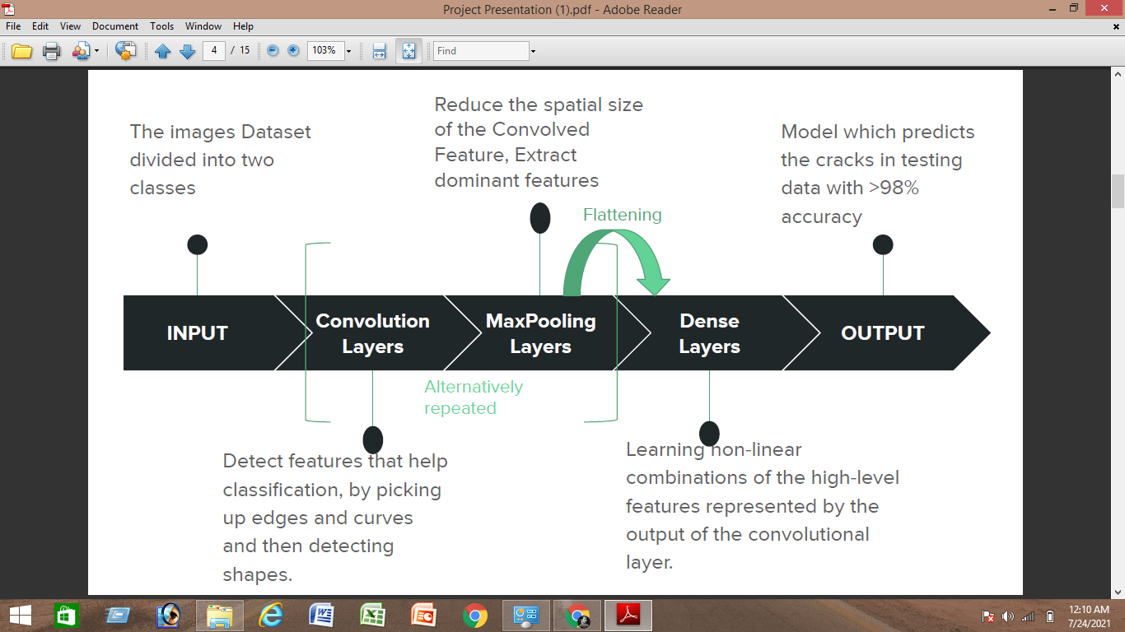

Fig3 : Block Diagram of Model

**SAMPLE CODE**

**LINK**

[**https://www.kaggle.com/mirajulhoque/surface-crack-detection**](https://www.kaggle.com/mirajulhoque/surface-crack-detection)

Fig4 : Accuracy Result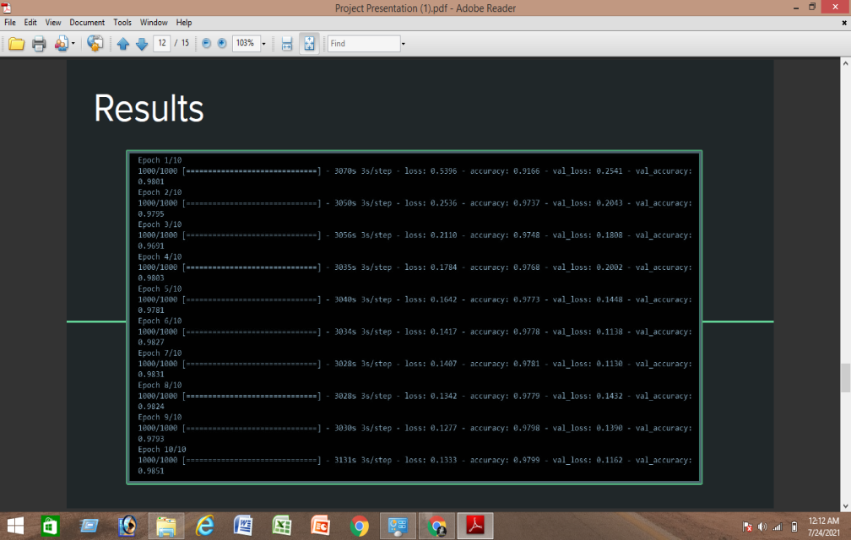

**SAMPLE OUTPUT**

**Visualization Plotting in Graphs**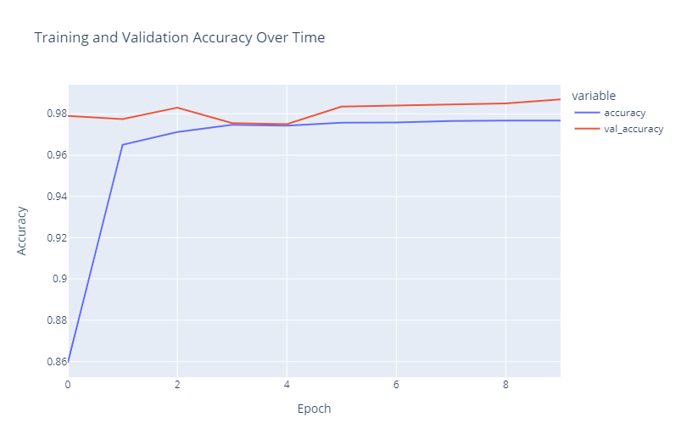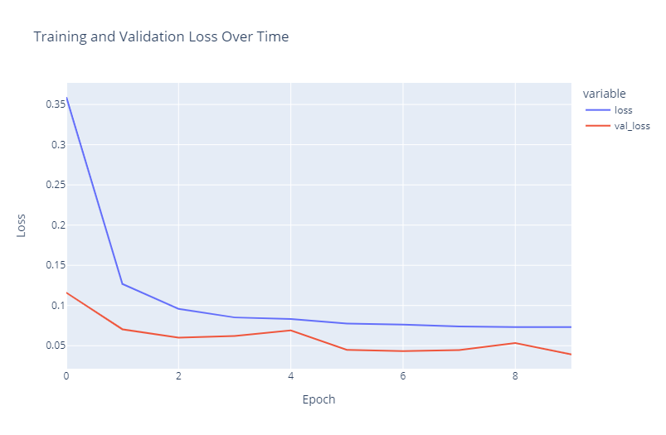

Fig5 : Visualization Plotting in Graphs Accuracy & Loss

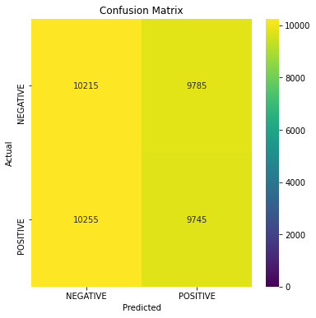

Fig 6: Predicted Matrix Block

**We got 9745 correct predictions out of 10255 records in the test set.**

**INPUT IMAGE**

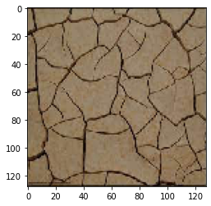

Fig7 : Crack Image.

**OUT PUT**

**1.0**

**Probability that the sample has a Crack = 1.0**

**Crack Detected !**

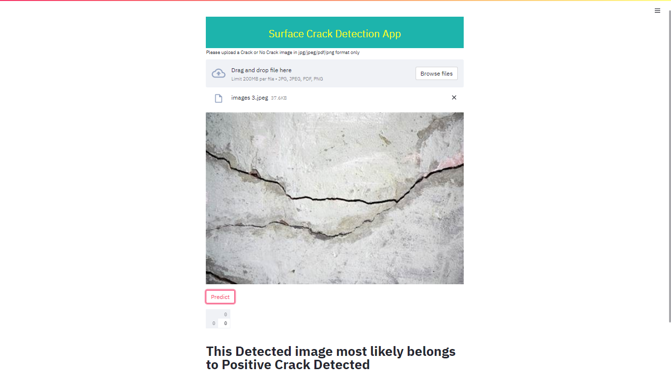

Fig 8: Launch app.py Interface

**CONCLUSION**

A convolutional neural networks-based approach to detect cracks using smartphones is proposed in this paper. A CNN used for crack detection is designed through modifying the GoogLeNet. A large number of images needed for CNN training, validation and testing are collected using a smartphone. Then those crack images are cropped into small images with **128×128 pixel** resolutions to build a database. A total of **40000** small images for building training and validation sets are included in the database. The CNN is trained using the datasets and recorded the highest validation accuracy of **98%**. To make it more public to detect cracks in practice, the trained CNN model is integrated into a smartphone application named Crack Detector. It is concluded that the proposed method can detect cracks indeed, and the created smartphone application makes the crack detection convenient.

This paper provides the collective survey of the different image processing techniques used for the detection of the cracks in the engineering structures. The main intention of this study was to study and review the crack detection system based on image processing. Here we have taken 15 research papers for the review based on crack detection. We have finalized our review based on the analysis of the five features. The first one is objective based analysis on to which the objectives like the length of the crack, width of the crack, direction of propagation of the crack are considered. Secondly, the datasets utilized for the methodologies were analyzed upon which we conclude that most of the system uses real data sets for the convenience as well as efficiency. Next, the analyses based on the accuracy level as well as the error level in some cases are scrutinized. Finally, we have performed the analysis based on the image processing techniques used in each system. And also we present the research issues which can be useful for the further research on the image processing based crack detection system. Based on the analysis, we conclude that more researchers have used the camera type image for the analysis with better segmentation algorithms like threshold technique and reconstructable feature extraction technique for the thorough damage analysis. In the future, we plan to conduct a survey on the different techniques available for invasive method based crack detection as this work presents an extensive study over the noninvasive methods of crack detection.

##### Acknowledgment

##### The success and final outcome of this project required a lot of guidance and support from many people and I extremely privileged to have got this all along the completion of this project. All that we have done due to our team and i would not forget to thank them. I respect and thank **Mr. Anirban Bose**, for providing an opportunity to do the project work on online and giving us all support and guidance which made to complete this project duly. I extermely thankful to him for providing such a nice support and guidance, although he had busy schedule managing the corporate affairs. I owe my deep gratitude to our project guide **Mirajul Hoque, Sattrajit Saha, Shouvik Khan, Somnath Das** and **Parthajit Rana** who took keep interest on our project work and guided us all along, till the completion of our project by providing all the necessary information for developing a good system. I would not forget to remember all depertmental faculties of Mechanical of Meghnad Saha Institute of Technology for their encouragement and more over for their timely support and fortunate enough to get constant encouragement, support and guidance from all teaching staff of Mechanical which helped us in successfully completing this project work.

##### References

1. Yamaguchi, T., Nakamura, S., Saegusa, R., and Hashimoto, S., “Image‐based crack detection for real concrete surfaces,” IEEJ T. Electr. Electr. 3(1), 128-135 (2010).
2. Oliveira, H. and Lobato Correia, P. “Automatic road crack segmentation using entropy and image dynamic thresholding,” Proc. EUSIPCO 2009, 622-626 (2009).
3. Santhi B., Krishnamurthy G., Siddharth S., Ramakrishnan P.K., “Automatic detection of cracks in pavements using edge detection operator,” J. Theor. App. Inf. Technol. 36(2), 199-205 (2012).
4. Abdelqader, I., Abudayyeh, O., and Kelly, M. E., “Analysis of edge-detection techniques for crack identification in bridges,” J. Comput. Civil Eng. 17(4), 255-263 (2003).
5. [Online]<https://scholar.google.com/>
6. Sinha, S. K. and Fieguth, P. W. Neuro-fuzzy network for the classification of buried pipe defects. Automation in Construction, 15(1), 73–83, 2006
7. Zhang, L., Yang, F., Zhang Y. D. and Zhu, Y. J. Road Crack Detection Using Deep Convolutional Neural Network In 2016 IEEE International Conference on Image Processing (ICIP), Phoenix, USA, 2016.
8. Eisenbach, M., Stricker, R., Debes K. and Gross, H.M. Crack Detection with an Interactive and Adaptive Video Inspection System In Arbeitsgruppentagung Infrastrukturmanagement, pages 94–103, 2017.
9. Pauly, L., Peel H., Luo, S., Hogg, D. and Fuentes, R. Deeper Networks for Pavement Crack Detection In Proceedings of the 34th ISARC. 34th International Symposium in Automation and Robotics in Construction, pages 479–485 Taipei, Taiwan, 2017.
10. Cha, Y.J., Choi, W. and Büyüköztürk O., Deep Learning Based Crack Damage Detection Using Convolutional Neural Networks, Computer-Aided Civil and Infrastructure Engineering, 32(5): 361–378, 2017.
11. Krizhevsky, A., Sutskever, I. and Hinton, G. E. ImageNet Classification with Deep Convolutional Neural Networks In Advances In Neural Information Processing Systems25 (NIPS 2012), pages 1097-1105, Nevada, USA, 2012.
12. Simonyan K. and Zisserman A. Very Deep Convolutional Networks for Large-Scale Image Recognition In International Conference on Learning Representations (ICRL), pages 1–14, Vancouver, Canada, 2015.
13. Szegedy, C., Liu, W., Jia, Y., Sermanet, P., Reed, S., Anguelov, D., Erhan, D., Vanhoucke, V. and Rabinovich, A. Going deeper with convolutions In Proceedings of the IEEE Computer Society Conference on Computer Vision and Pattern Recognition, pages 1-9, Boston, USA, 2015.
14. He, K., Zhang, X., Ren, S. and Sun, J. Deep Residual Learning for Image Recognition In 2016 IEEE Conference on Computer Vision and Pattern Recognition (CVPR), pages 770–778, Seattle, USA 2016.
15. Gopalakrishnan, K., Khaitan, S. K., Choudhary, A. and Agrawal, A. Deep Convolutional Neural Networks with transfer learning for computer vision-based data-driven pavement distress detection Construction and Building Materials, 157(September):322–330, 2017.